# Procurement of an Online Payment Services

The purpose of this document is to provide results of a research done in selecting an online payment processing provider. Three provides were researched and

## Company profile

“Safari Jewelry and Such!” is a privately owned and operated small business. It is licensed as a Limited Liability Corporation. Our main source of revenue is through sales of handmade jewelry and handbags. Its roadmap does not preclude other items in the fashion industry. The company will benefit from a service provider that can accommodate in areas peripheral to payment processing. These are:

* Tax services
* Legal services
* Inventory management
* Customer service (refunds, order management, etc.)
* Shopping cart management
* Fraud protection

### Company1: CyberSource

Description: Cybersource is a Payment Management services company. They provide solutions for Merchants and Partners. The solutions they provide to Merchants is listed below:

* Payment Processing
* Payment Security
* Fraud management
* Other services
* Merchant Solutions
* Partner Solutions

The last three solutions are consultancy and specialty services which businesses can use to grow their business.

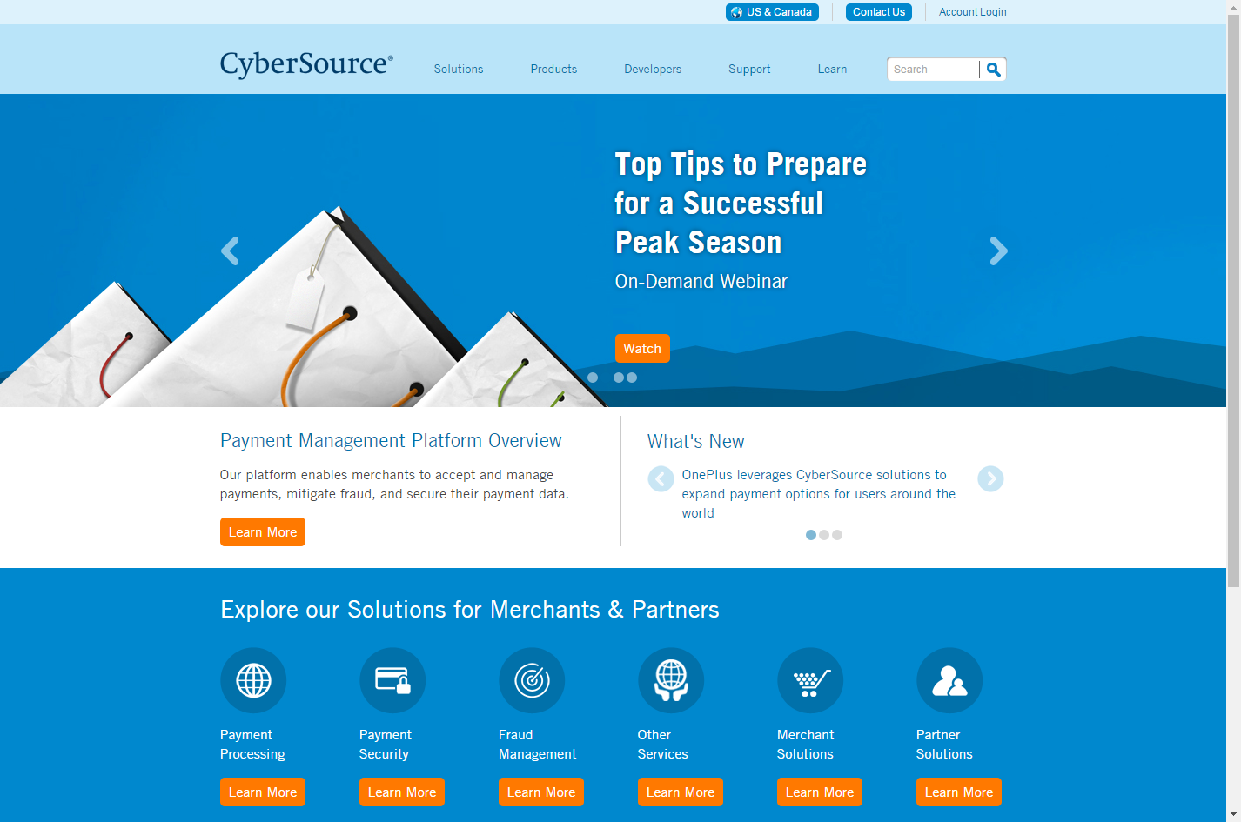

Figure 1- CyberSource web site

With Payment Processing, businesses can accept cards and alternate payment across all sales channels such as Mobile, Web, Point-of-Sale and call center. Other services offered with payment processing listed in their web site is shown below.

* Cross-Channel Payments
  + Accept payments across mobile, web, point-of-sale, and call center channels
  + Facilitate cross-channel purchases and back-end integrations
  + Enable a common view of customer activity across channels
* Gateway & Processing Connections
  + Connect to approximately 100 processors across the globe
  + Change processor connections with minimal impact
  + Use prebuilt integrations to connect commerce platforms and back-end systems    (ERP, OMS, etc.)
* Payment Cards
  + Accept a wide range of universal and regional cards in over 190 countries
  + Experience high-speed processing speed and reliability
  + Add more card types easily
* Online and Mobile Digital Payments
  + Accept popular online digital payments (aka eWallets)
  + Reduce checkout friction
  + Increase payment options
  + Accept mobile digital payments like Apple Pay® and Android Pay™
  + Increase speed to pay for your repeat customers
* Direct Debits and Bank transfers
  + Accept direct debit payments
  + Accept bank transfer payments, including iDEAL, Giropay, etc.
  + Ensure compliance with SEPA regulations
* Reconciliation Reports
  + Easily and accurately reconcile payment activity with bank statements
  + Consolidate reporting across processors, payment types and channels
  + Produce reports in multiple formats and frequencies
* Rules based Payer Authentication
  + One connection to 3D Secure
  + Includes Verified by Visa, MasterCard SecureCode, SafeKey, J/Secure programs
  + Limited chargeback liability on qualifying transactions
  + Works with any payment system
* Global Tax Calculation
  + Help ensure fast and accurate tax calculation, within the country and across the  
    globe
  + Calculate a wide range of taxes including local levies and Value Added Tax (VAT)
  + Avoid the need to manage an additional service
* Recurring Billing
  + Automate your recurring and subscription revenue streams
  + Configure payment schedules and customer communications for your business
  + Integrate with services like CyberSource Tokenization to keep payment data out of  
    your environment
* Account Updater
  + Keep vital customer payment information current
  + Reduce risk of failed transactions and service termination
  + Avoid unnecessary customer interactions on payment-related issues

### Company2: YahooStores!

Description: Yahoo stores is a one-stop shop for everything from hosting a website to needed by an e-commerce business. Figure 2 shows the services they provide. With respect to online payment, once a store is setup on their site, they are automatically setup to receive payments from American Express, Discover, Visa, MasterCard, and PayPal. They will also be able to integrate with UPS to print labels, customize shipping rates and much more.

YahooStores offers tools to help grow the business. Tools such as Search Engine Optimization, Insights and Recommendations and live monitoring customers, live chat to assist customers and increase conversion rate which is essential in success of an e-commerce business.

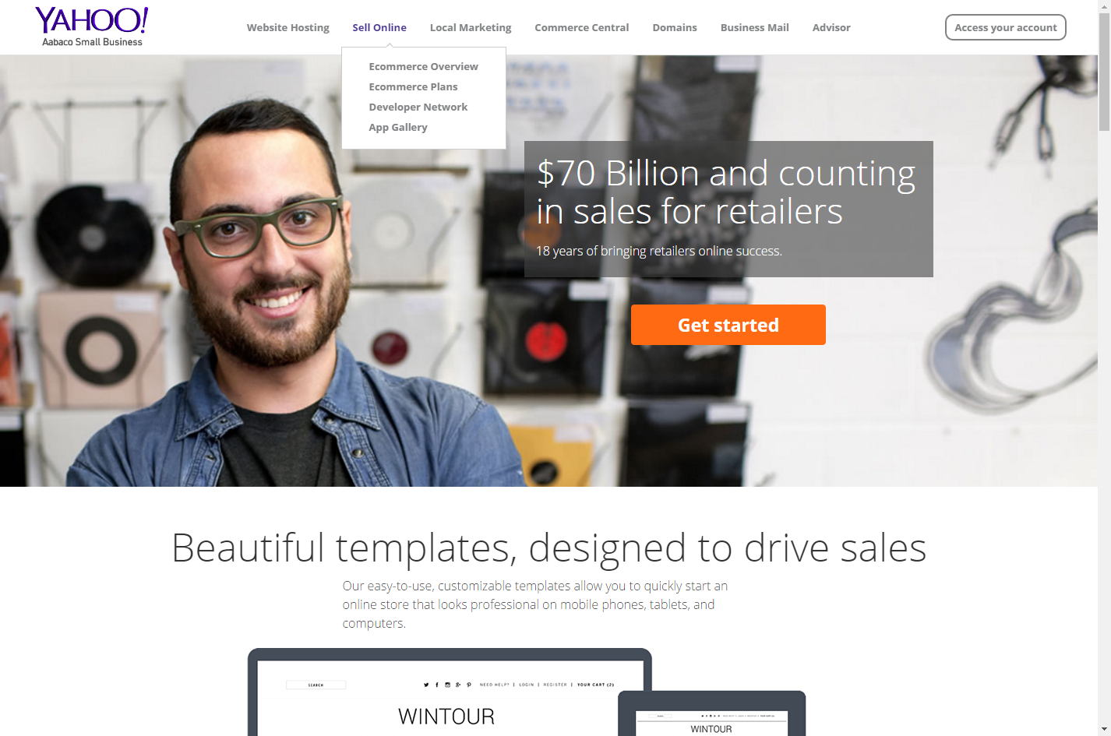

Figure - YahooStores! Site

Their e-Commerce plans is shown in Figure 2. The transaction fee is applied to the final price of the item sold. This price does not include Tax and Shipment charges.

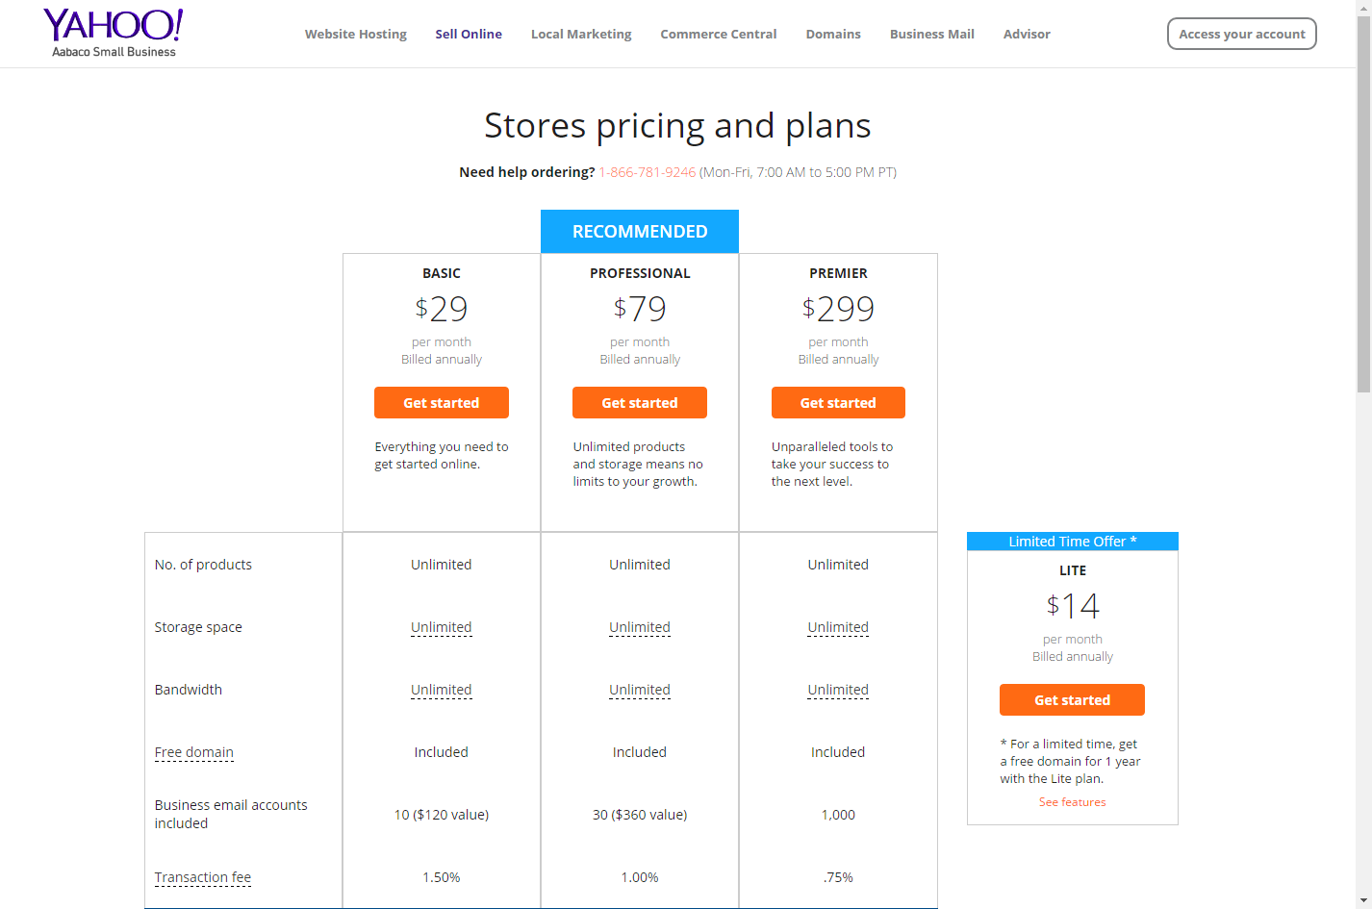

Figure - YahooStores Store pricing and plans

### Company3: PayPal

Description: PayPal is widely known and used method to purchase items without using credit Card., bank account or from their balance in the PayPal account. Customers register method(s) of payment with PayPal, and then every time they make a purchase using PayPal, the selected method of payment will be applied to the purchase (i.e. Bank Transfer or Credit Card).

Businesses who wish to offer PayPal as a method of payment can benefit from these payment methods as well. In effect, PayPal becomes a one-stop shop for ALL payment methods. To accept PayPal as a method of payment, businesses add their Button to their web site’s checkout page.

PayPal required signing up in order to see more features they offer. Once signed on, we saw the following services and features:

* Summary Page show amount of money available,
* Recent activities,
* creating an Invoice for customers
* Tax documents and reports
* Resolution center to report problems with shipping to communication with the buyers.

They offer fraud protection, 24-hour monitoring and encryption. They also offer PayPal Seller Protection on eligible purchases. Snapshot below shows more info on their security features.

Initial sign up as a seller was quick; however, to sign up to accept payments and such will require TAXID, legal business name, and other legal items.

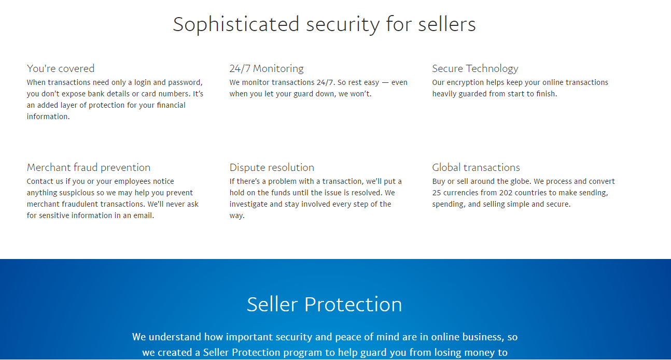

Figure - PayPal Security Tools

Signing up for a business account is also simple. The menu of options is shown in Figure 4. The differentiating factor between the “Payment Pro” and the other two options is that with “Payment Pro” businesses can customize their checkout forms as shown is Figure 5.

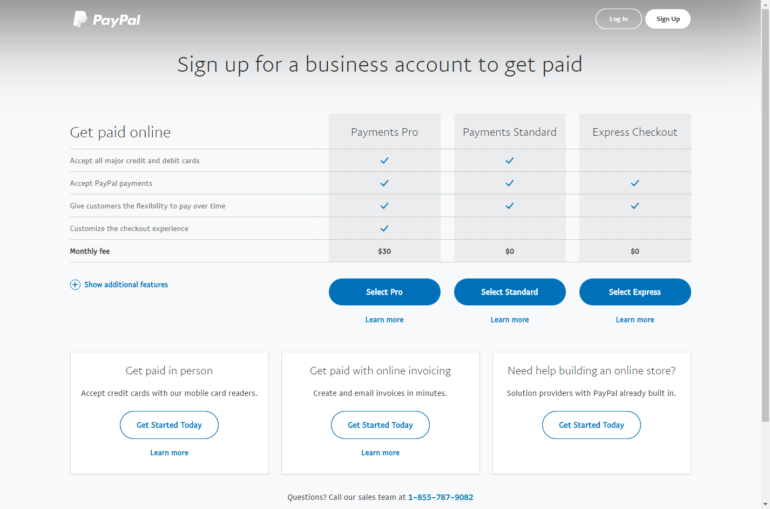

Figure - PayPal business account options

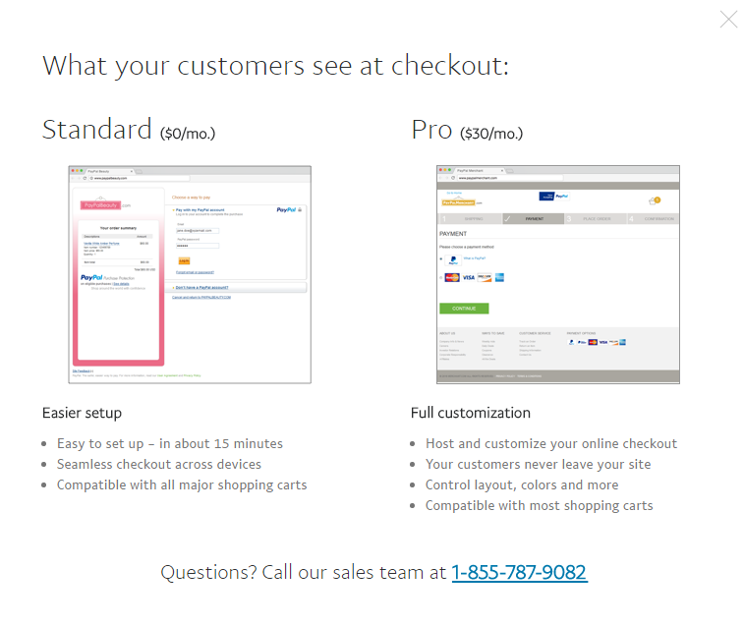

Figure - Checkout experience

# Research Result & Conclusion

The three products that we compared can be ranked from “focused on Payment Processing” to “payment processing AND other tools to grow an e-commerce business”. PayPal falls on the “focused” category, with CycberSource offering additional grown capability to YahhoStores that offers turnkey solution is all aspects from web design, to creating stores to stocking the stores and ultimately selling and getting paid.

We could not ascertain the price model from CyberSource web site; however, the price comparison between PayPal and YahhoStores would put PayPal at an advantage especially since PayPal doesn’t assess a fee per transaction.

Given the size of our business and the trajectory of our growth, we recommend using PayPal in the short term with the goral to transition to yahooStores in the long-term and beyond.